UNIVERSITY OF CENTRAL PUNJAB



Syntax Analysis (Parser) for S++ (Siraiki++)

Name: Hafiz Abdul Hannan

Reg No: L1F22BSCS0322

Section: G-10

Submitted To: Ms. Aneela Mehmood

Github-link: https://github.com/HafizAbdulHannan/Siraiki-Lexical-Analyzer

Compiler Construction: Project Phase 2
Project - Introduction:

The objective of Phase 02 is to design and implement a Syntax Analyzer (Parser) for the custom language S++ (Siraiki++) created in Phase 01. The parser validates the grammatical structure of programs produced using the tokens, keywords, operators, and punctuations defined in the lexical analyzer.
This phase focuses on Context Free Grammars (CFG), parsing techniques using YACC/Bison, and integration with the Flex scanner.
.
Language Overview (S++ Extension):
Language Name: S++ (Siraiki++)
In this phase, the lexical analyzer from Phase 01 is reused without changing previously defined tokens. The language supports the following constructs using Siraiki keywords:
- Variable Declaration (adad, isharia, akhar)
- Loops (valval for For-loop, jitna for While-loop)
- Conditions (jay for If, natan for Else)
- Input/Output (ghin for Input, likh for Output)
- Functions (wadda for Main)
Context Free Grammar (CFG):
The following production rules have been implemented in parser.y to define the structure of S++.
Non-Terminals are shown in lowercase and Terminals (Tokens) in UPPERCASE.
- program ---> start_func
- start_func ---> KEYWORD_VOID KEYWORD_MAIN PUNC_LPAREN PUNC_RPAREN block | KEYWORD_INT KEYWORD_MAIN PUNC_LPAREN PUNC_RPAREN block
- block ---> PUNC_LBRACE statement_list PUNC_RBRACE
- statement_list ---> statement statement_list | ᶓ (empty)
- statement ---> declaration_stmt | assignment_stmt | io_stmt | if_stmt | loop_stmt | return_stmt | break_stmt | block
- declaration_stmt ---> type IDENTIFIER OP_ASSIGN expression PUNC_SEMICOLON | type IDENTIFIER PUNC_SEMICOLON
- type ---> KEYWORD_INT | KEYWORD_FLOAT | KEYWORD_CHAR
- assignment_stmt ---> IDENTIFIER OP_ASSIGN expression PUNC_SEMICOLON
- io_stmt ---> KEYWORD_COUT OP_STREAM_OUT output_chain PUNC_SEMICOLON | KEYWORD_CIN OP_STREAM_IN IDENTIFIER PUNC_SEMICOLON
- if_stmt ---> KEYWORD_IF PUNC_LPAREN condition PUNC_RPAREN block | KEYWORD_IF PUNC_LPAREN condition PUNC_RPAREN block KEYWORD_ELSE block
- loop_stmt ---> KEYWORD_FOR PUNC_LPAREN for_init condition PUNC_SEMICOLON for_update PUNC_RPAREN block | KEYWORD_WHILE PUNC_LPAREN condition PUNC_RPAREN block
- expression ---> term | expression OP_PLUS term | expression OP_MINUS term
- term ---> factor | term OP_MULTIPLY factor | term OP_DIVIDE factor
FIRST and FOLLOW Sets:
Non-Terminal | FIRST Set | FOLLOW Set
program | { wila, adad } | { $ }
statement | { adad, isharia, akhar, ID, likh, ghin, jay, valval, jitna, wapas, khal, { } | { }, adad, isharia, akhar, ID, likh, ghin, jay, valval, jitna, wapas, khal }
type | { adad, isharia, akhar } | { ID }
block | { { } | { $, adad, isharia, akhar, ID, likh, ghin, jay, valval, jitna, wapas, khal }

Parse Tree:
Below is the Parse Tree for a valid statement: wila wadda() { adad x = 10; }.
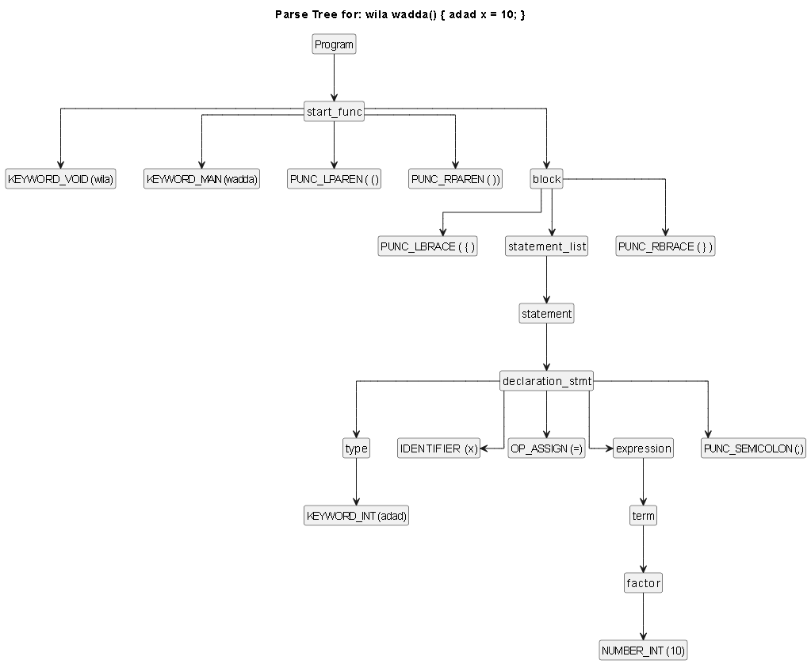

Implementation Details

Token Integration (Phase 01 to Phase 02):

The tokens defined in the Flex scanner (scanner.l) are integrated into the YACC parser (parser.y) using the %token directive.
- Scanner: Returns tokens like return KEYWORD_INT; when "adad" is found.
- Parser: Declares %token KEYWORD_INT and uses it in grammar rules like type: KEYWORD_INT.

Error Handling:

The parser uses the yyerror() function to report syntax errors.
- It prints the Line Number where the error occurred.
- It uses verbose error reporting to show the Unexpected Token and the Expected Token

Testing and Output:

Input-code:

wila wadda() {
adad x = 10;
likh << "Program shuru";
wapas 0;
}

Output:

Syntax Analysis Successful! (Mubarak Ho).

“Error-Code”

Input-code:

wila wadda() {
adad x = 10 // Semicolon missing
}
Output:

Error at Line 2: syntax error, unexpected PUNC_RBRACE, expecting PUNC_COMMA or PUNC_SEMICOLON.

“Screenshot”

